The following steps will install the latest Eclipse IDE and if necessary the

JDK (Java Development Kit).

**STEP 1 Visit the Eclipse Web Site**

Open the following URL on your Web browser.

**http://www.eclipse.org/downloads/packages/eclipse-ide-java-ee-developers/neonr**

On the right hand side of the page choose you operating system under ‘Download Links’.

Once you are taken to the Eclipse download page, you can click the download link.



Click the zip file when the download completes and unzip the file to a

desired location on your computer (typical place would be the to the root of your

C: drive).

If you don’t have java or an updated version of JDK (Java Development Kit) version 1.8 loaded in your system proceed to Step 2 before you run the Eclipse exectuable after you’ve unzipped your file to your location.

**STEP 2 Visit the Java Web Site as an option IF you don’t have java (the jdk**

**etc.) loaded on your system.**

With Eclipse loaded on your computer you can now visit the Oracle Web site to download the latest Java JDK ( Java Developers Kit ) .

[**http://www.oracle.com/technetwork/java/javase/downloads**](http://www.oracle.com/technetwork/java/javase/downloads)

Click on the following icon (shown on the next page) to be taken to a page that lists the various platforms to download.

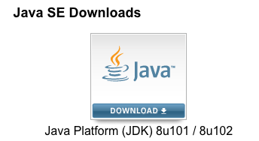

Review and accept the license agreement and then download the Java JDK 8 (ex. **jdk-8u101-windows-x64.exe** ) for your particular operating system.

When the download completes, double click the executable file and load the

jdk/jre files to the default location listed which is typically under the directory

**C:\Program Files\Java**. Restart if necessary to complete the install.